APPLICATION FOR PARTICIPATION IN THE EXHIBITION

Venue: Exhibition Complex "LenExpo"
St. Petersburg, V.O. Bolshoy pr. D. 103
September 14-16, 2017
Global Fishery Forum & SeaFood Expo
1. ORGANIZER

LLC "ESG EXPO"  Tel .: +7 (499) 922-44-17, +7 (499) 963-80-08  Actual address: 127018, Moscow, ul. Polkovaya, 3, b. B / N , 1st entrance, 2nd floor  Legal address: 127018, Moscow, ul. Polkovaya, 3, room 30  7725322671/771501001 | Fill in the application form at:  info@rusfishexpo.com
2. PARTICIPANT

Company name on the exposition plan Место для ввода текста.
Contact person Место для ввода текста.
Phone Место для ввода текста.
E-mail Место для ввода текста.
Full company name Место для ввода текста.
Actual address (full) Место для ввода текста.
Legal address (full) Место для ввода текста.
INN Место для ввода текста. PPC Место для ввода текста.
C/A Место для ввода текста. Bank Место для ввода текста.
Head of the company Место для ввода текста.
Position Место для ввода текста. Operates on the basis Место для ввода текста.
3. Direction of the activity of the Participant
Tel .: +7 (499) 922-44-17, +7 (499) 963-80-08
Actual address: 127018, Moscow, ul. Polkovaya, 3, b. B / N », 1st entrance, 2nd floor
Legal address: 127018, Moscow, ul. Polkovaya, 3, room 30
INN / KPP 7725322671/771501001

☐ Fishery companies
☐ Fish Processing Companies
☐ Shipbuilding companies
☐ Manufacturers / suppliers of fish processing equipment
☐ Manufacturers / suppliers of fishing equipment
☐ Manufacturers / suppliers of workwear
☐ Manufacturers / suppliers of geonavigational equipment
☐ Manufacturers / suppliers of software
☐ Warehousing and logistics companies
☐ Retailers / Distributors
☐ Owners of cafes and restaurants
☐ Other
4. The subject of the contract and the cost of participation

The cost of participation is formed of three components: registration fee, rent of exhibition space and building.
Registration is mandatory for all exhibitors. It includes organizational expenses, expenses for the SeaFood Expo information and advertising campaign, the cost of general protection of the territory and the external perimeter of the exhibition pavilion, the provision of a control and access regime on the territory of the exhibition complex, provision of public and fire safety, cleaning of the general area of ​​the exhibition hall, publication Information about the Participant on the website of the exhibition.

Exhibition area: | Cost 1 square meter, in rubles. | The size of the stand, In sq.m. | Total cost of the stand:
Registration fee | 23 000 rub. | 1 | 23 000
Rent of exhibition space | 16 000 rub. | 0
Construction Category A | 20 000 rub. | 0
Construction Category C | 15 500 rub. | 0
Total:

Rent of the exhibition area includes the provision of temporary use (rent) of unequipped space in the pavilion (the rent includes the general protection of the pavilion and cleaning of the passages during the Exhibition). Electrical connection, other technical connections, buildings and equipment are not included in the cost of unequipped space and are ordered additionally.
5. Types of construction

Construction Category A
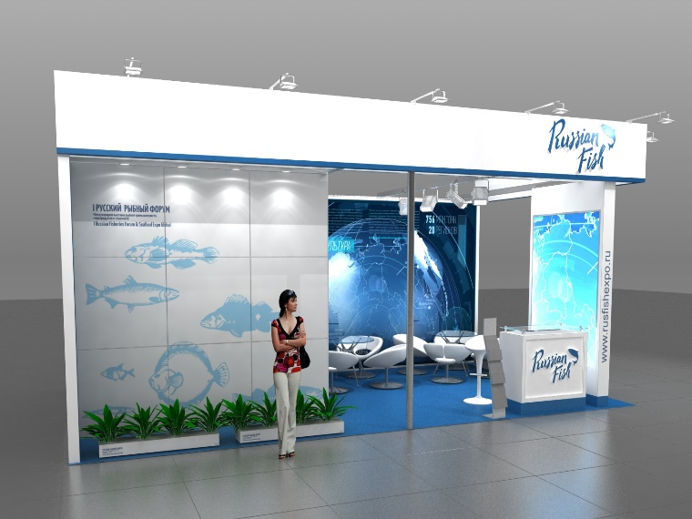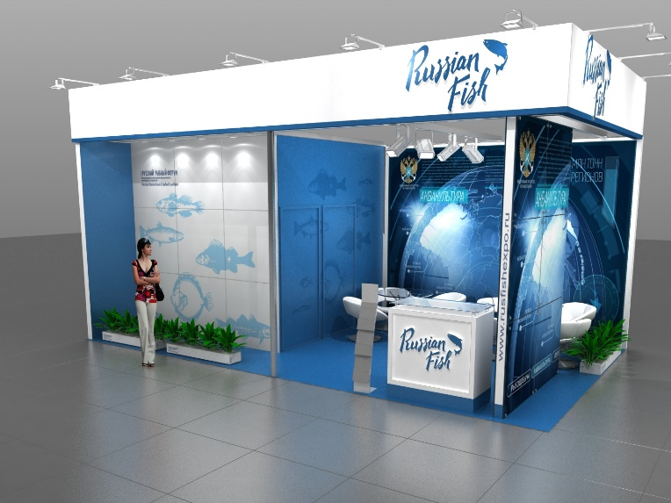

Construction Category C
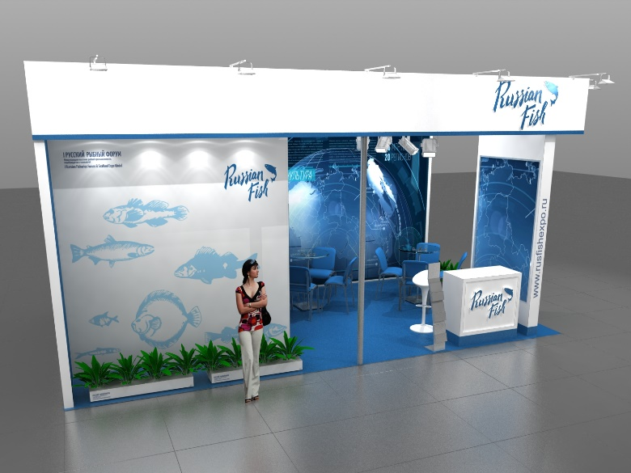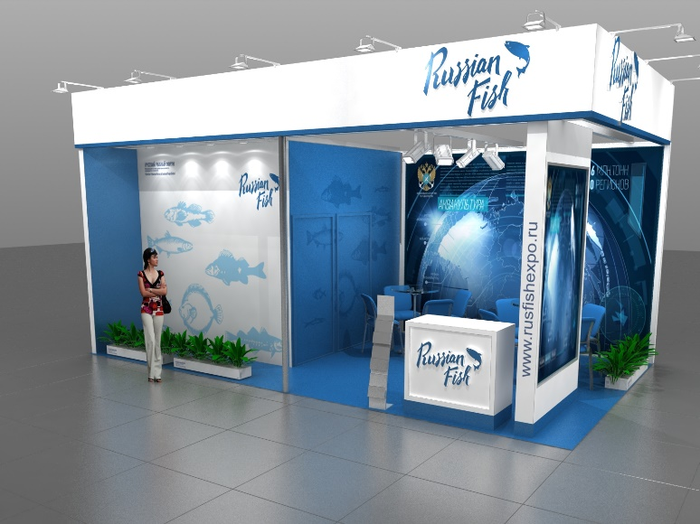

OPTIONAL EQUIPMENT
Multimedia, refrigeration and other equipment, as well as furniture in larger quantities is not included in the basic equipment of the stand and is paid additionally!
The list of additional equipment and cost are indicated in the Exhibitor's Handbook in the corresponding section.

